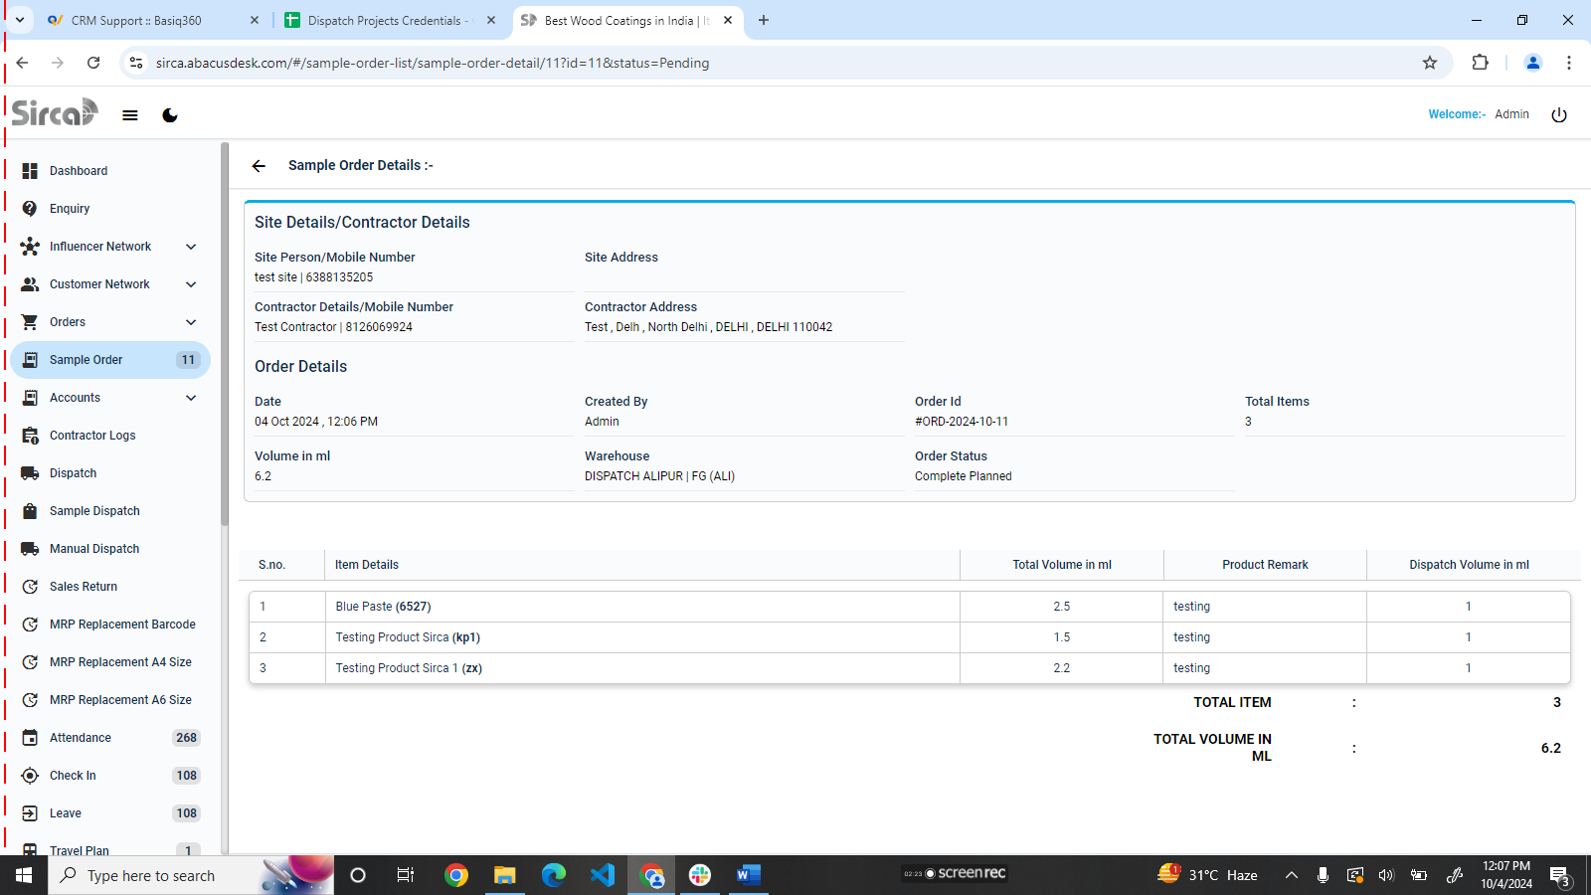



Sirca mai dispatch volume in ml dispatch planning krte time galat hai

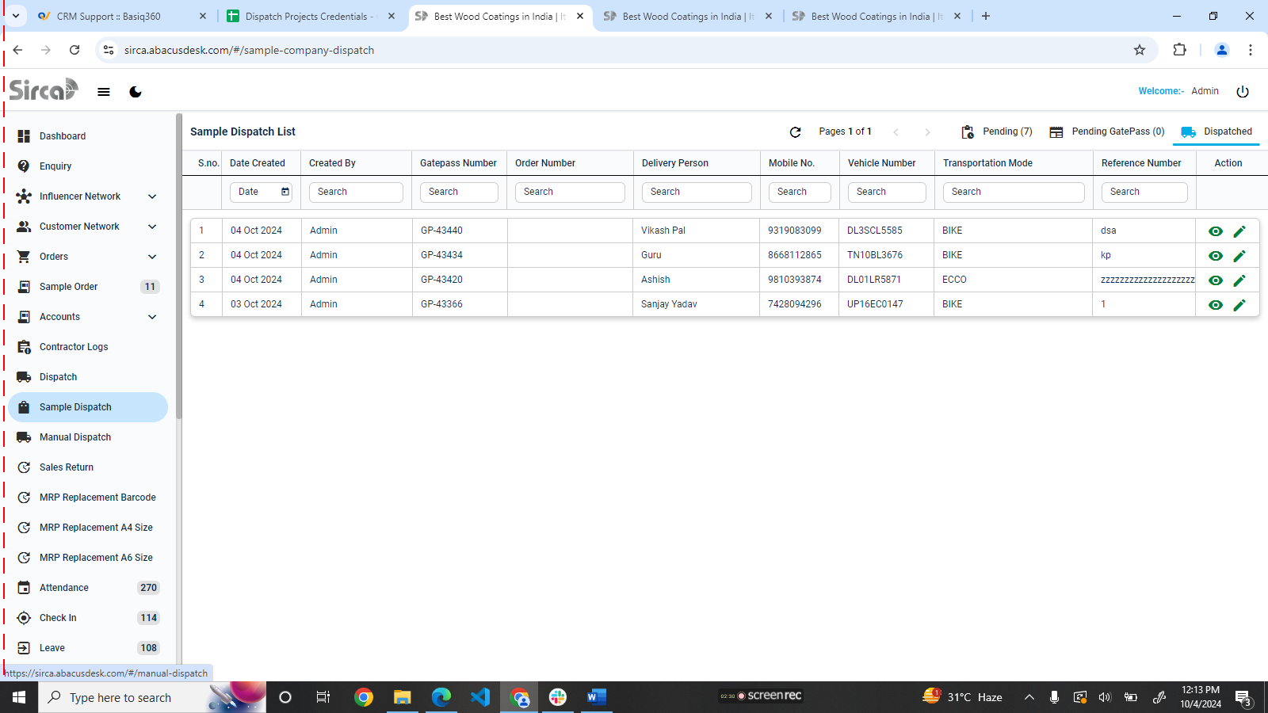



Sample dispatch mai order move hone k baad order number k column mai show nhi ho rha haii

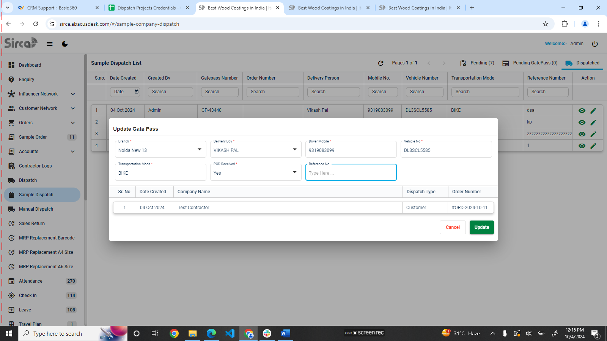



Sample dispatch mai order move hone k baad Reference Number edit krn pr

not e—sab filtr krn e hai s earching filtr working nhi hai